This question is from:

<http://www.mhprofessional.com/product.php?isbn=0071420401>

**Schaum's Outline of Programming with Java, by John Hubbard, McGraw Hill**

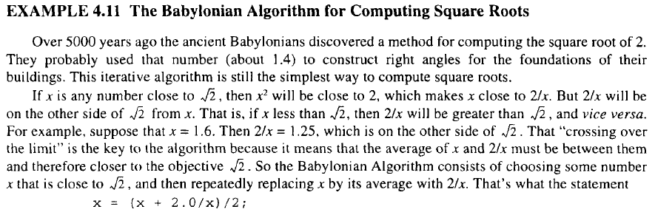

The above definition indicates the solution for finding the square root of 2. However, the approach can be generalized to find the square-root of any positive real value, ***c***, using the following iterative solution:

$$x=(x+\frac{c}{x})/2$$